Visual insights report

1]

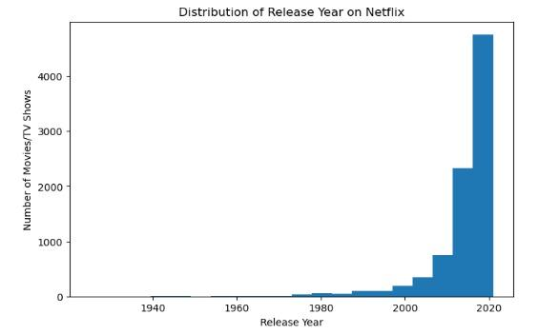

This graph shows the distribution of content based on release year.
Most titles were released after 2015, which shows a rapid increase in content in recent years.

2] 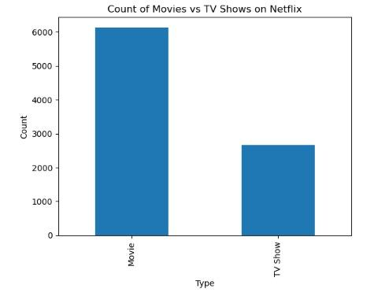

This graph compares the number of Movies and TV Shows.
Movies are more than TV Shows, indicating that Netflix focuses more on movies.

3]

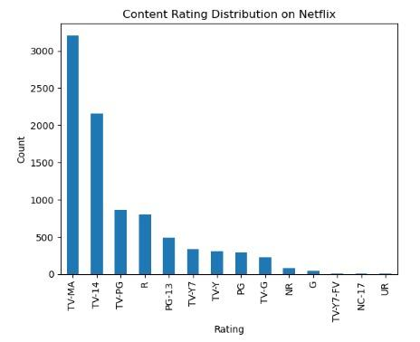

This graph shows the distribution of content ratings.
TV-MA and TV-14 are the most common ratings, meaning most content is for mature audiences.

4]
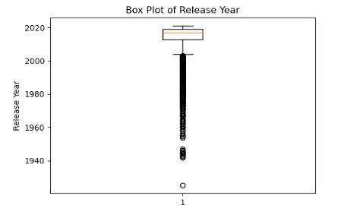

This graph shows the spread of content duration.
Most titles have similar duration, but a few titles have very high duration, which are outliers.

5 ]

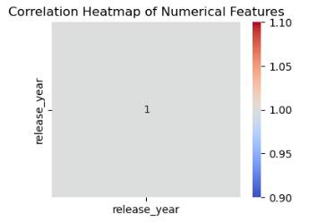

This graph shows the correlation between numerical features.
There is no strong correlation between most features, indicating independent behavior.

6] Important Features for Prediction

Based on EDA, content type, release year, rating, and duration are important features.
These features show clear patterns and can be useful for prediction tasks.

7] Overall Summary

Most Netflix content was released after 2015
Movies are more common than TV Shows
Mature ratings are dominant
Duration contains some outliers

